Vocabulary

1 Fill in: *grab*, *defeat*, *represent*, *commemorate*, *encourage*, *fight*, *exchange*, *decorate*, *greet*, *fast*.

**1** My parents always ……………………. me to learn about other cultures.

**2** In Russia, people usually ……………………. cards and presents on New Year’s Day.

**3** Sachin has to ……………………. during Ramadan and he can’t eat anything all day.

**4** We hold Gasparilla Pirate Festival to ………………. the life of a Spanish pirate.

**5** In the past, soldiers used to ………………. with swords and spears.

**6** We decided to ……………………. the house with balloons for Kelly’s party.

**7** Jim’s grandparents always ……………………. him with a big smile.

**8** People wear costumes at the festival to ……………………. the seasons.

**9** Just wait while I ……………………. my coat and then we can leave.

**10** The Mexican army managed to ……….……. the French at the Battle of Puebla.

Marks: ____

10×0.5 5

2 Underline the correct item.

**1** There were lots of impressive floats in the street **parade/display**.

**2** We went to the hospital to visit Helen after the **birth/birthday** of her baby boy.

**3** On New Year’s Eve hundreds of cities **bring/come** alive with colourful fireworks.

**4** In February children in Greece **wear/dress up** in carnival costumes.

**5** Charlie **spilled/slipped** some tea on the white carpet.

**6** In some countries, the wedding celebrations **keep/last** for several days.

**7** Maria **put up/turned up** to the party in the same dress as her sister.

**8** The English **celebrate/hold** Bonfire Night on the 5th of November every year.

**9** Congratulations on passing your final exams! When is your **graduation/ crowning**?

**10** Stan **stepped/fell** on Mike’s foot while we were dancing.

Marks: ____

10×0.5 5

Grammar

3 Put the verbs in brackets into the *present perfect*.

**1** I ......................................... **(not/try)** Maori food – what’s it like?

**2** ......................................... **(you/see)** Emma today?

**3** Jason ................................... **(just/break)** a glass and there are pieces of it all over the floor.

**4** They ......................................... **(be)** at the celebration since 9.00 this morning.

**5** ......................................... **(Alex/buy)** a ticket for the festival?

Marks: ____

5×1 5

4 Underline the correct answer.

**1** Lucy hasn’t seen her cousins in Australia **for/since** two years.

**2** The graduation ceremony has **yet/just** started.

**3** Have you **never/ever** taken part in a parade?

**4** I haven’t been to the Glastonbury Festival **since/for** 2010.

**5** They haven’t picked the winner of the competition **yet/already.**

Marks: ____

5×1 5

5 Complete the exchanges using the *present perfect* or the *past simple*.

**1** A: I   
**(buy)** Fiona a birthday present yesterday.

B: Really? I   
 **(not/get)** her anything yet.

**2** A:   
**(you/ever/visit)** the Taj Mahal?

B: Yes, I   
**(go)** there in 2010.

**3** A: I   
**(take part)** in a Mexican festival last summer.

B: You’re so lucky! I   
 **(never/be)** to Mexico.

**4** A: Max   
 **(just/graduate)** from university.

B: That’s great! He   
 **(study)** really hard   
for his exams last month.

**5** A: Laura   
 **(already/chose)** her   
costume for the parade.

B: I know. She   
 **(show)** it to me   
last night – it’s beautiful.

Marks: ____

5×1 5

Everyday English

6 Read the dialogues (1-3). Complete the dialogues (1-3) with appropriate responses by circling the appropriate letter (A, B or C).

**1** X:Did you do anything special at the weekend?

Y:

**A** I enjoyed it a lot.

**B** I went to a wedding.

**C** It was really special.

**2** X:

Y: Yes, we usually have a family meal at home.

**A** How do you celebrate your birthday?

**B** Who do you celebrate your birthday with?

**C** Do you celebrate your birthday?

**3** X: What are you wearing to Daisy’s graduation?

Y:

X:Really? Maybe I should go shopping too!

**A** My suit was on sale.

**B** I’ve bought a new suit.

**C** I think you should wear a suit.

Marks: ____

3×5 15

Reading

7 Read the text below, from which four sentences are missing. Fill the gaps (1-4) with appropriate sentences (A-E). Write appropriate letters (A, B, C, D or E) in the gaps. One sentence is extra and does not match any of the gaps.

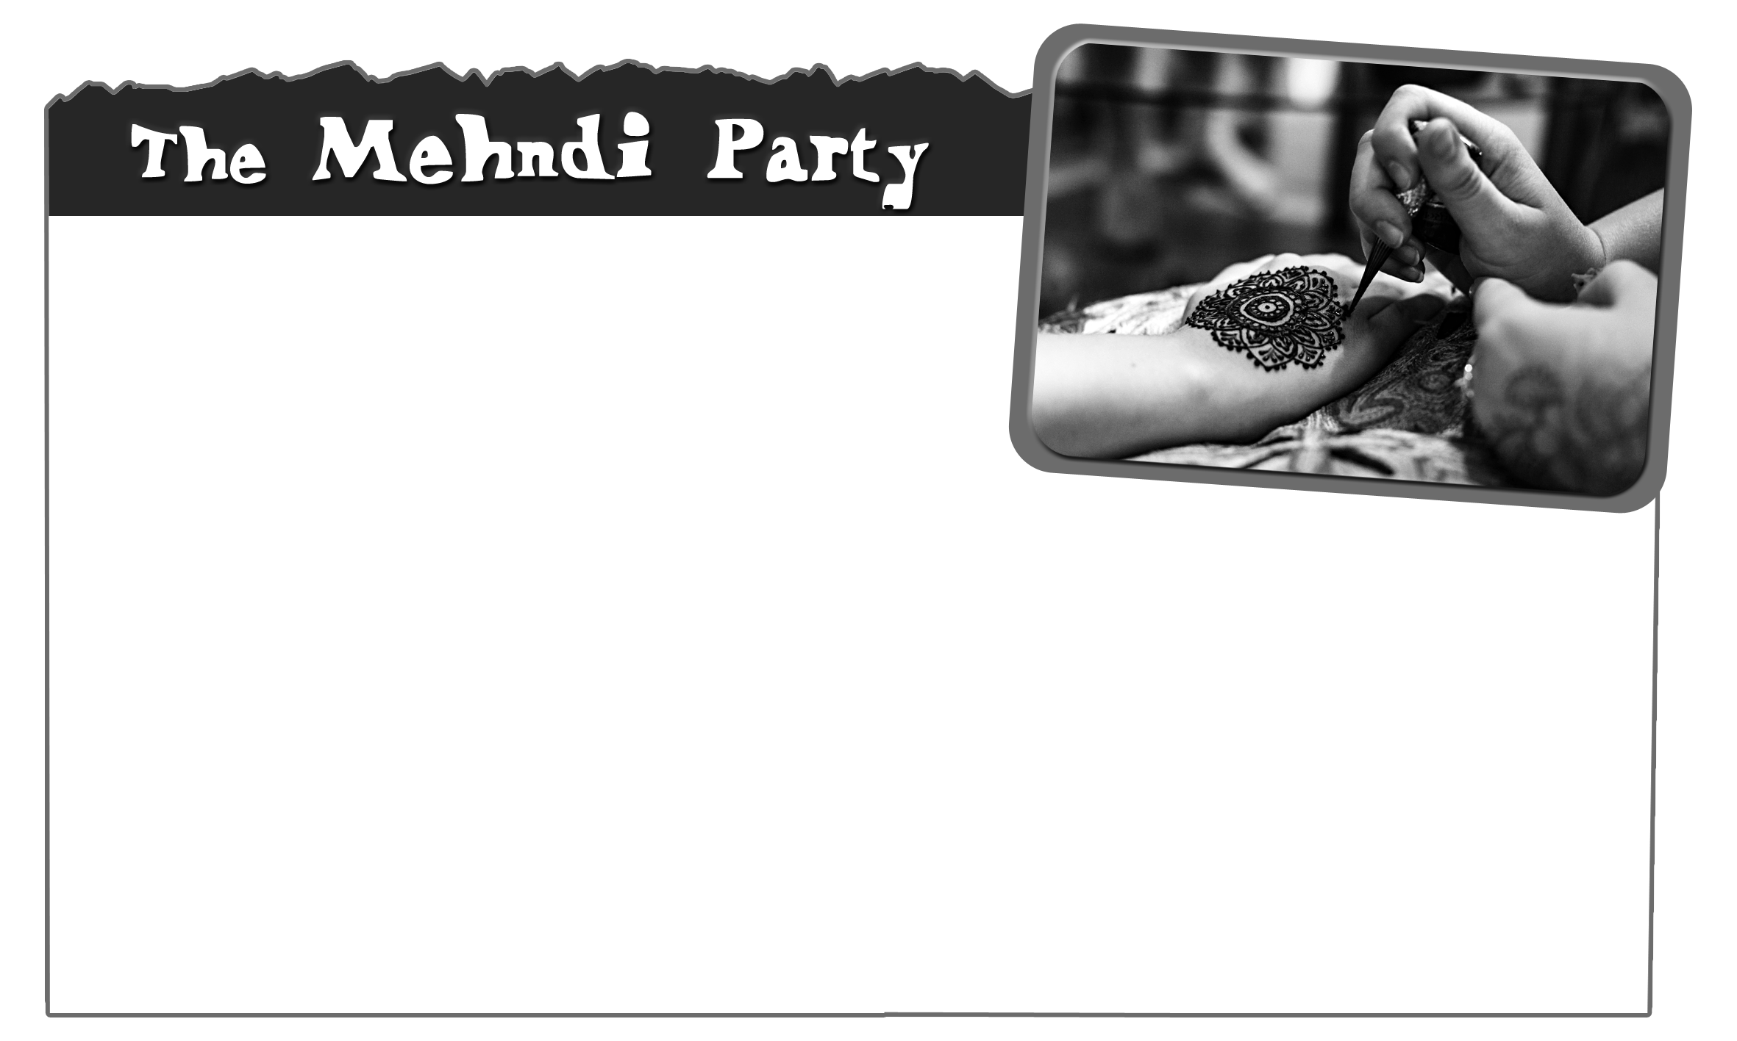

Hindu weddings are elaborate occasions that take   
place over several days. One important part of the   
festivities is the Mehndi Party.  It is called the   
Mehndi Party after the dye used to paint patterns on the skin of the bride, also   
called mehndi. This is a paste made from the dried leaves of a plant, mixed with lemon juice or water.  An artist uses the mehndi to paint complicated designs on the bride’s hands and feet, so she has to sit still for hours.  They also have designs painted on their skin.  A popular belief is that the longer the pattern remains on the bride’s skin, the more the groom and his family love her.

**A** This is why the other women sing and dance to entertain her.

**B** The groom’s name is often hidden in the pattern on her hands.

**C** The mehndi patterns last for 2-4 weeks.

**D** This celebration is only for the bride and her relatives.

**E** It is usually reddish-brown, the colour of luck.

Marks: ____

4×5 20

Writing

9 You have just returned from a big celebration. Write an email to your English-speaking friend (50-100 words). In your email:

• say where you went

• describe who was with you and what you did

• explain what was special about it

To: Ben@fast.net

From: [user21@turbospeed.com](mailto:user21@turbospeed.com)

Subject: The celebration!

Marks: ____

20